Getting Started with Zoom
How to set up your Zoom account:
Step 1: Open a web browser, navigate to rochester.zoom.us
Step 2: Click on “Log In”, then click on UR NetID
Step 3: Put in your NetID and password

Important Settings to change:
These settings can be found on rochester.zoom.us once you log in, and navigate to the “Settings” tab.
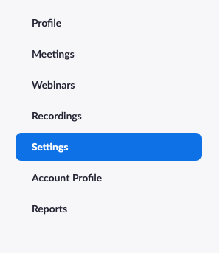
Note: If the setting toggle is grey, that means the setting is OFF. If the setting toggle is blue, that means the setting is ON.
Under the Meeting section, under Schedule Meeting
Join before Host – Turn this OFF

Mute Participants upon Entry – Turn this ON
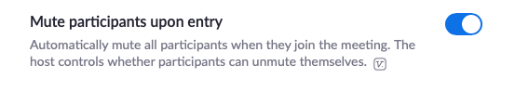
Under the Recording section
Automatic Recording – if you would like Zoom to automatically record each session when it begins, turn this ON
