Musicians Guide to Video Conferencing

Covid-19 is affecting everyone in the entertainment industry. The purpose of this blog is to give you the best chance to provide a good experience for your students. Now that digital lessons have become the new norm for so many, great effort will be placed on quality of musical playback through video conferencing.

This guide will:
- Break down best practices for video conferencing regarding hardware and setup
- Focus on getting the best audio quality possible with what you have
- Provide “good, better, best” recommendations for equipment to invest in
- Give personalized scenarios for setting up your studio

This guide is not for:
- Lecturers/students who don’t require playing an instrument for online lessons. Zoom/skype/facetime/hangouts are good enough for spoken voice.
- Those who are content getting by with the sound and video that they are getting
- Those who want to put in the least amount of effort possible, as this forced online learning environment will be temporary. This is perfectly okay!
- Those looking for specific settings in video conferencing software to optimize their audio. Other resources have already been provided to answer this question.

Computer vs Phone vs Tablet

The best results I have had for obtaining the highest quality audio is to use Zoom.us on a Mac or PC. I don’t recommend using a phone or tablet if you are looking to get the best possible quality. Remember, we are mainly after using video conferencing to share live-performed classical and jazz music, which by nature has extreme subtleties. Although newer phones and tablets can do a good job, the options to add on supplemental equipment is limited, and the quality obtained from purchasing these add-on products is not worth the investment. Avoid the trap of the products below:
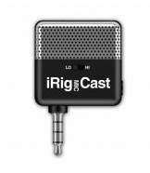
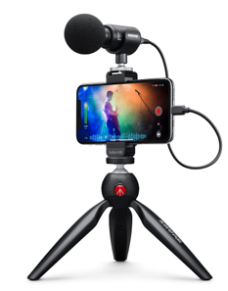
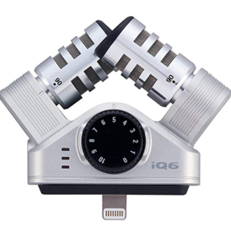

These are alluring because of their price point and ease, however, I believe many students and teachers of classical and jazz music are about to find out:

These microphones are just not going to cut it.

USB Microphones – (Easy)

The use of a standalone USB microphone is a very simple solution for drastically improved audio quality both in terms of spoken voice and musical recording. With a USB microphone, you just plug it directly into your computer. That’s it! USB microphones produce very good quality, especially considering the price point and ease, however they still will not produce professional results for the world of classical and jazz music. Also, their application is limited to video conferencing only, as these microphones can not be used for professional recording purposes. Still, they provide a very good value.

There are 2 recommendations I have for USB microphones. I personally would avoid all others.

- $100 Rode NT-USB Mini - This is brand new, and personally I think this microphone has the best sound overall. This can be used with the Rode PSA-1. Note: This uses USB-C.
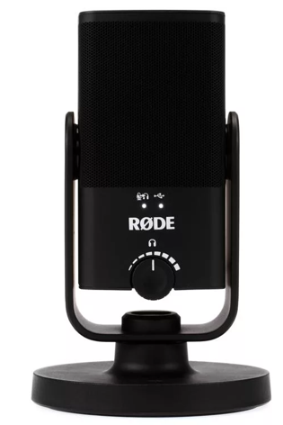
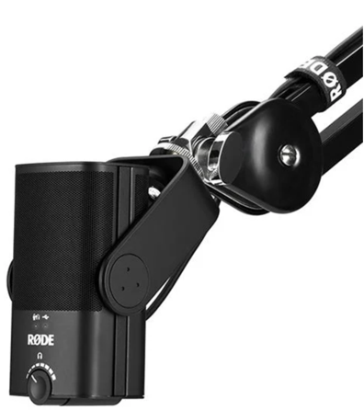

- $129 Blue Yeti – Industry standard and #1 selling USB mic in the world. Pick any color!
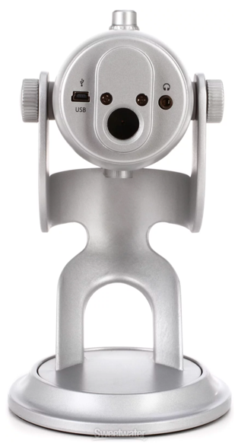
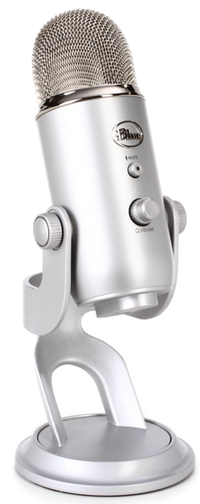
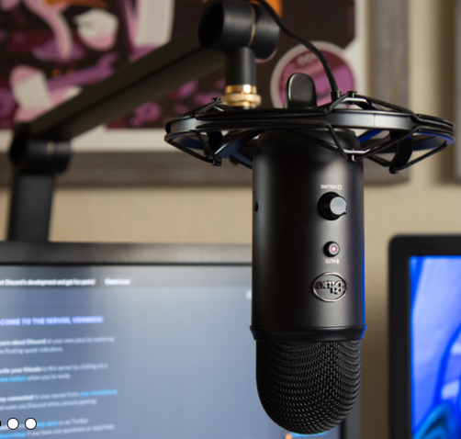

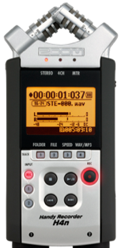
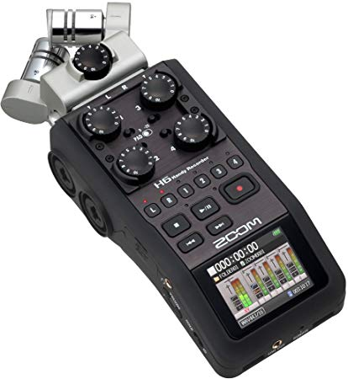
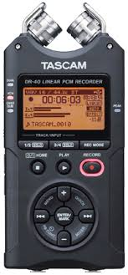

Field Recorders - (Intermediate)

I understand that making any investment into equipment can be a huge burden, and an unexpected expense. In the situation where you don’t want to spend any money, there may be some equipment that you already own or can borrow from a friend that can be used to improve your audio recording quality. Many of the audio devices from companies like Zoom and Tascam make their field recorders to double as a USB audio interface. This is great news for you! This means you can use your field recorder as an external microphone with your Mac or PC!

Here are links to video tutorials for Zoom and Tascam audio interfaces that I have found to be most common among my peers and within the music community:

Tascam DR Series https://www.youtube.com/watch?v=pzRfyUP46hg
Zoom H1N https://www.youtube.com/watch?v=IrJuIIRjCJ0

If you have a different brand of field recorder, I would recommend doing a Google search for “Using my _______ as an audio interface” to find a setup tutorial video.

Mounting your field recorder
There are many possibilities. Here are 3 solutions:
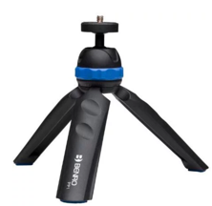
- $20 - Benro Mini Tripod
This mini tripod can be used to mount your field recorder. I recommend it for instruments you can sit down at your desk and still play, such as guitar, oboe, bassoon, etc. It also comes with a phone attachment.
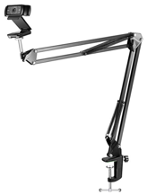
- $20 - Neewer desk Mount (Better price)
- $99 - Rode PSA-1 (Better quality)
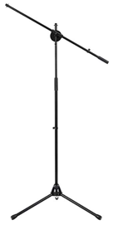
Mount your field recorder, microphone, OR a webcam. These arms can be versatile if you need to quickly move your audio or video source to a more catered angle for your instrument or voice. I highly recommend it for instruments where standing is ideal for playing. Make sure your desk can accommodate the clamp.
(To mount your field recorder to the Rode PSA-1 you will also need this adapter.)

- $15 Microphone stand with $25 ball head
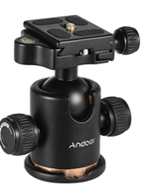
This basic mic stand accommodates two attachments allowing possibility for both webcam and field recorder. However, you may find it to be limiting.

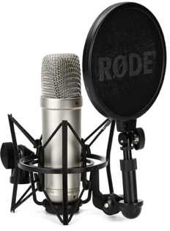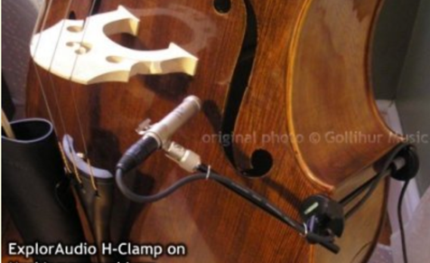

XLR Microphones with Field Recorder – (Advanced)
If you have a field recorder that you’d like to use as audio interface, you’re set! This would be the bare minimum to improving your quality without spending any money. However, if you already own or want to invest into professional microphones that could be used for self-recording as well as video conferencing, you could purchase XLR microphones. Purchasing these adds a step in the process because they cannot be plugged into a computer directly without an audio interface. With some field recorders, you can plug in XLR microphones directly, as with the Zoom H4n, H5, or H6. This makes your field recorder an audio interface. These extra microphones could be placed on or near your instrument using proper mic placement which would allow for everything to be set in place.
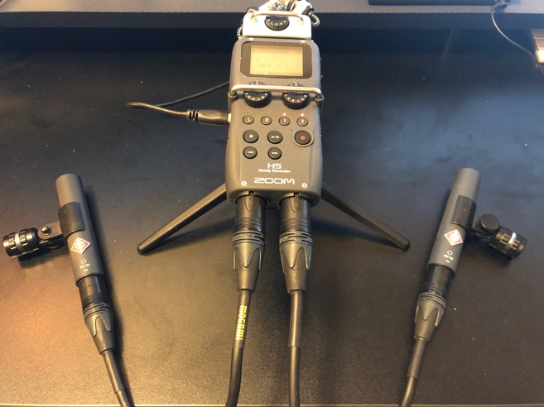

This will yield noticeably better results. However, depending on the equipment you already have, it still may also require a large investment. Also, the kind of microphone that you use matters - not all microphones are created equal.

Real talk.
I understand that spending a lot of money on additional gear may not be something that many are able to do, however, I would argue that if you need to spend money on an investment, you might as well invest into equipment that has multiple uses, and will represent your brand as a musician accordingly. Recording yourself is a vital skill for any musician or teacher, and can save you hundreds of dollars for each recording session you would need to hire an engineer for. I’m not trying to put myself out of work, I am an audio engineer. Please, hire me! But with your best interest in mind, I recommend to every musician in 2020 that they have the ability to make a quality recording of themselves. I speculate that after the societal reboot, online learning will become even more mainstream. For those not interested or unable to spend more than $100 for a USB microphone, you can use additional guidance in this article for research.

XLR Microphones with Audio Interface – (Advanced)

For all of the choices previously discussed, these are ways to do the job with what you have, or by spending the least amount of money. Now, let’s discuss the tools that professionals use to do the job the right way.

An Audio interface combined with professional microphones is the ideal way to capture yourself as a classical or jazz musician. How does it work? Here’s a routing diagram. Your microphones connect to the audio interface, and the audio interface connects to your computer. It also acts as a hub for your speakers, headphones, and volume controls for all of these things. In short, they are awesome.

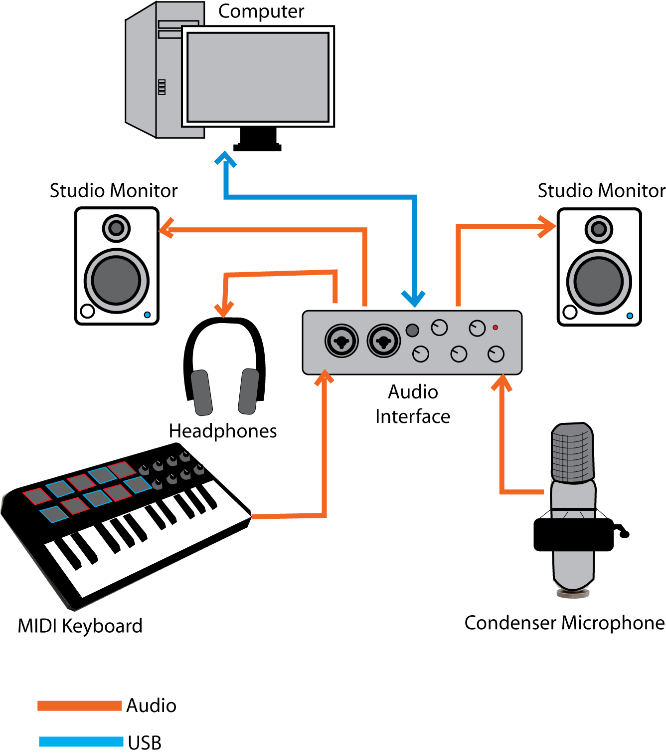

Audio Interface Recommendations

There are so many choices in this field that it’s very difficult to pick a clear winner. The one constant I have found: you get what you pay for. For that reason, I am including my top 5 choices, in price order. I would go with whichever you can afford.

- $159 - Focusrite Scarlett 2i2
This is the baseline 2-channel USB audio interface and would be the lowest I would go. It will do a solid job when combined with a good microphone.

- $499 – Universal Audio Arrow (Mac/PC with Thunderbolt 3 ONLY)
This until is a significant upgrade compared to the first choice regarding quality of sound. It’s also small in form, and BUS powered, meaning it’s very portable and can be powered from your Mac/PC with Thunderbolt 3. You also receive some incredible audio improvement plugins that make this a very versatile choice. As far as value and versatility is concerned, this would be my first choice.

- $659 – Focusrite Clarett 4Pre
This interface has a large upgrade over the quality of sound from the Focusrite Scarlett. It also has 4 inputs which allows for greater flexibility.

- $899 - RME Babyface Pro
RME is known for it’s transparency. This 2-channel interface will allow for premium quality sound and enters the realm of professional dynamic range.

- $1799 – Universal Audio Apollo x4
This Thunderbolt 3 interface has all of the same perks as the Arrow, but with four channels instead of two. This flexibility comes at a premium price, but is an ideal setup and package to future-proof yourself for years to come.

Microphone Recommendations by Instrument

My microphone recommendations and mount vary by instrument. Below you will find a chart showing the instrument and 3 microphone choices designed as a “good, better, best” scenario. For live video conferencing, I feel that investing into better or best categories may be overkill due to bandwidth limits. However, if you plan to use these microphones for self-recording offline, you will absolutely hear the benefits. Professional microphones will record using a full dynamic range and will sound natural when placed correctly.

Instrument | Mic Choice $ | Mic Choice $$ | Mic Choice $$$ | Mount/Acces.
Violin/Viola | Stereo Pair  (Entry level) | Stereo Pair  (Natural sound) | Stereo Pair  (Professional sound) | Boom Stand  Stereo Bar  Mic Cables
Cello | Stereo Pair  (Entry level) | Stereo Pair  (Natural sound) | Stereo Pair  (Professional sound) | Boom Stand  Stereo Bar  Mic Cables
Classical Bass | Stereo Pair  (Entry level) | Stereo Pair  (Natural sound) | Stereo Pair  (Professional sound) | Boom Stand  Stereo Bar  Mic Cables
Jazz Bass | Single Mic  (Entry level) | Single Mic  (Natural sound) | Single Mic  (Professional sound) | H-Clamp  Mic Cable
Saxophone | Stereo Pair  (Entry level) | Stereo Pair  (Natural sound) | Stereo Pair  (Professional sound) | Boom Stand  Stereo Bar  Mic Cables
Clarinet | Stereo Pair  (Entry level) | Stereo Pair  (Natural sound) | Stereo Pair  (Professional sound) | Boom Stand  Stereo Bar  Mic Cables
Flute | Stereo Pair  (Entry level) | Stereo Pair  (Natural sound) | Stereo Pair  (Professional sound) | Boom Stand  Stereo Bar  Mic Cables
Oboe | Stereo Pair  (Entry level) | Stereo Pair  (Natural sound) | Stereo Pair  (Professional sound) | Boom Stand  Stereo Bar  Mic Cables
Bassoon | Stereo Pair  (Entry level) | Stereo Pair  (Natural sound) | Stereo Pair  (Professional sound) | Boom Stand  Stereo Bar  Mic Cables
French horn | Stereo Pair  (Entry level) | Stereo Pair  (Natural sound) | Stereo Pair  (Professional sound) | Boom Stand  Stereo Bar  Mic Cables
Trumpet | Single Mic  (Entry level) | Single Mic  (Natural sound) | Single Mic  (Professional sound) | Boom Stand  Mic Cable
Trombone | Single Mic  (Entry level) | Single Mic  (Natural sound) | Single Mic  (Professional sound) | Boom Stand  Mic Cable
Acoustic Piano | Stereo Pair  (Entry level) | Stereo Pair  (Natural sound)  (Mounts included) | Stereo Pair  (Professional sound) | Boom Stand  Stereo Bar  Mic Cables
Organ | Stereo Pair  (Entry level) | Stereo Pair  (Natural sound) | Stereo Pair  (Professional sound) | 12’ Stand  Stereo Bar  Mic Cables
Drumset – Jazz  (Note: options for individual drum mics are not included here) | Stereo Pair  (Entry level) | Stereo Pair  (Natural sound) | Stereo Pair  (Professional sound) | Boom Stand  Stereo Bar  Mic Cables
Percussion | Stereo Pair  (Entry level) | Stereo Pair  (Natural sound) | Stereo Pair  (Professional sound) | Boom Stand  Stereo Bar  Mic Cables
Tuba | Single Mic  (Entry level) | Single Mic  (Natural sound) | Single Mic  (Professional sound) | Boom Stand  Mic Cable
Harp | Single Mic  (Entry level) | Stereo Pair  (Natural Sound)  (2 cables needed) | Stereo Mic  (Professional sound) | Boom Stand  Mic Cable
Classical Guitar | Single Mic  (Entry level) | Stereo Pair  (Natural Sound)  (2 cables needed) | Stereo Mic  (Professional sound) | Boom Stand  Mic Cable
Jazz Guitar | Single Mic  (Entry level)  Ideal for Amp | Single Mic  (Natural sound) Amp or Guitar body) | Single Mic  (Natural sound)  Amp or Guitar body) | Boom Stand  Mic Cable

Summary

Still working on this page

As you may be asking, what about video? I intended the focus to first be on getting up and running with a quality audio capture. I will write up another guide for obtaining the best video quality, but I’ve found the built-in webcams or Logitech webcams are quite good on their own.

Below I have summarized each package based upon the research above to make your purchasing decisions streamlined.

Scenario Suggestion 1 – Easy
Use a field recorder as an audio interface. Place on a desk mounted stand. Easy and done!

Equipment required
$0 Zoom or Tascam field recorder (Already owned)
$20 - Benro Mini Tripod

Scenario Suggestion 2 – Easy
Use a USB microphone on a desk or with a stand.

Equipment Package 1
$99 - Rode NT-USB Mini
$20 - Neewer desk Mount

Equipment Package 2
$186 – Blue Yeti with boom arm

Scenario Suggestion 3 – Intermediate
Use a field recorder as an audio interface, and add additional microphone(s) for high quality audio capture.

Package recommendations:

Package for seated instruments in front of a desk.

Package for standing instruments in front of a desk

Package for Pianists

