Getting Started with Box

How to log into your Box account for the first time:
Every student, faculty, and staff member who did not already have a University-managed Box account should have received an email with an invitation to join.
Step 1: Login into Box using the following address:
https://tech.rochester.edu/services/box/

Step 2: Once redirected to the University’s Box page, click on “Continue”
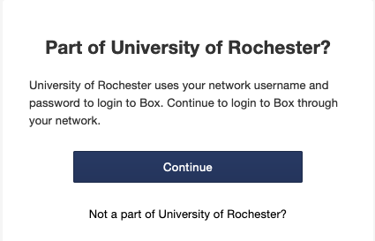
Step 3: Click “UR NetID”, and check the box next to “Remember my choice”, then click “Continue”
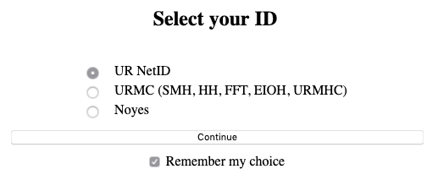
Step 4: Enter your NetID and password, then click “Login”
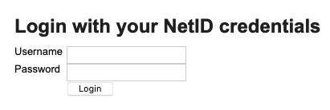

Setting up folders:
Step 1: Near the top right of the page, click the New button; select Folder.
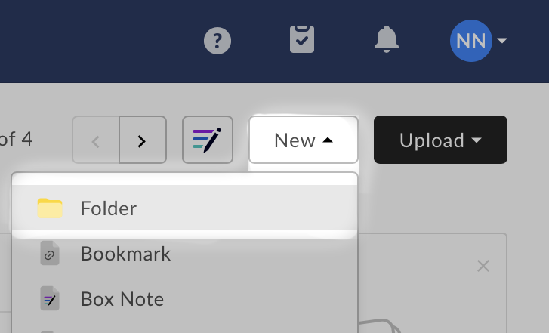

Step 2: Name your folder and click Create (you can invite people later)
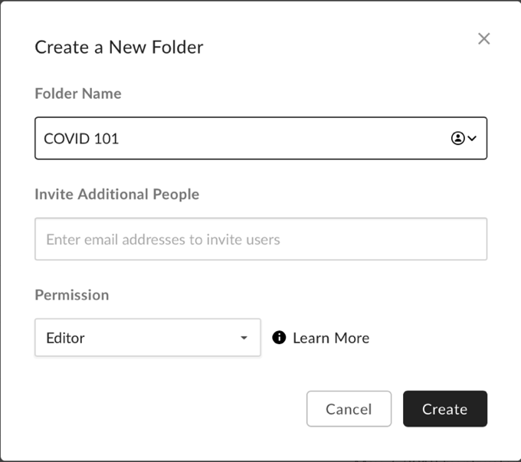
Step 3: Adjust your folder settings to restrict collaboration to within the University of Rochester
- Right-click your folder and select Settings
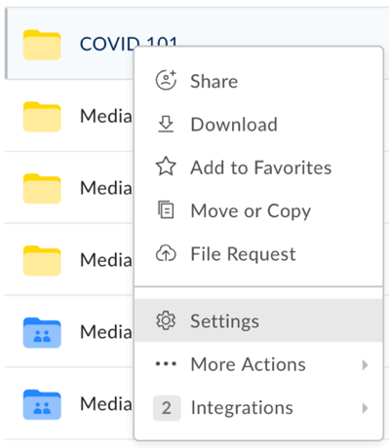

- Within Collaboration check Restrict collaboration to within University of Rochester

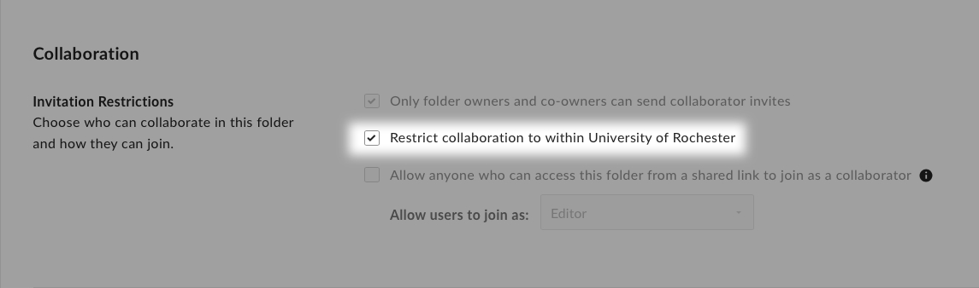

Sharing with others:
After you’ve created a folder, the easiest way to share it is to first select the folder, so that it is highlighted in blue.

Once selected, you will see a button on the right that says “Share” - click this, and a menu will pop up that allows you to input the email address(es) of your recipient(s) or get a link which you can then distribute through other communication channels.
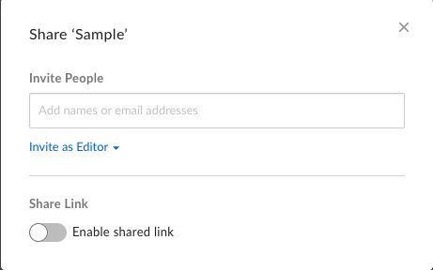

If you choose to input the email address(es) of your recipient(s), there are several options when it comes to sharing folders with others. Depending on your course, and your intended usage, you can select any of the following permissions.
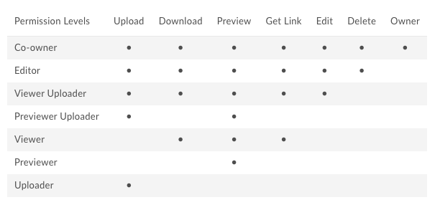
Co-Owner – has the highest level of access to the folder (same level of access as the creator of the folder)
Editor – can do everything except manage folder security
Viewer Uploader – can do most things except delete files within the folder and manage folder security
Viewer – can only download files from the folder, preview files within the folder, and get the link for the folder
Previewer Uploader – can only upload files to the folder and preview files within the folder
Previewer – can only preview files within the folder
Uploader – can only upload files to the folder

If you choose to enable the shared link, there are slightly different settings available.
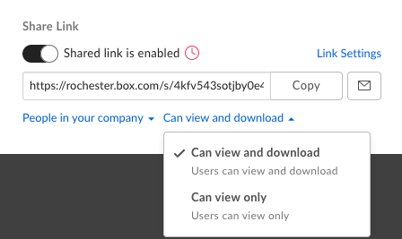
Further settings can be found by clicking “Link Settings” seen in blue above. Since these settings generally provide less control for instructors and less accessibility for students, we recommend inviting students directly to the folder by adding their email addresses.

Other tools:
Box has the ability to create and write notes. To create a note, click on the pen icon in the top right of the page. This will open a dialog box where you can name the note, and then click “Create”.
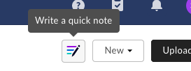
Box also has the ability to create a variety of document types, such as a Word document, a PowerPoint presentation, or a Google Doc. To create a document, click the New button in the top right of the page.
