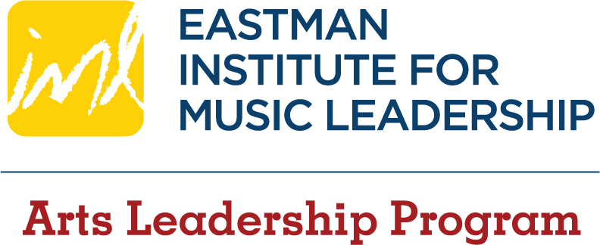 | Intern Statement of Intent  (Complete form & submit to ALP)

General Information
Applicant Name |  | Date

Summer/Academic Year internships - Students accepted into the Arts Leadership Program are required to fulfill
2 credits in an internship. Students may choose any combination of summer/academic year internships to fulfill their
2 credit requirement. Summer internships require a commitment of 120 hours for 1 credit. Academic year internships require a commitment of 85 hours for each semester for 1 credit per semester.

Intern Statement of Intent - We ask that those who will be considering any of these options complete this Intern Statement of Intent. This will help us in planning to make sure there are an adequate number of academic internships available as well as assist you in preparation of your applications due to the ALP office in April. You will not be held to this statement of intent should your plans change, but please keep the IML Assistant Director informed of your plans should they significantly change from what is presented on this form.

My Intent – Summer and/or Academic Year Internships
I anticipate doing a summer internship during the Summer of 2022 and plan to apply for funding through ALP on or before the deadline of March 31, 2022. If checked, please provide answers to BOTH of the following:
- A few sentences about what you’ve done so far. (Read emails sent by ALP re: summer internships, research on web or via networking contacts, names of organizations you’ve considered or contacted, what steps you’ve taken with them, etc.)
- Your tentative plan/timeline for the future. (Research, contacting organizations, etc.)
(additional space available at the end of this document if needed)

I anticipate doing an academic year internship during the year 2022-2023 and plan to apply through ALP on or before the deadline of March 31, 2022. I plan to intern:
For BOTH Fall and Spring semester
For one semester only (indicate semester option below):
Fall semester only
Spring semester only
Flexible on semester depending on needs of host organizations
I’m not sure – explain:

Additional Comments about any intern intent (summer or academic year)

